# **TITLE PAGE**

**Project Name: N-Queens Problem**

**Student Name: Rituraj kumar**

**Roll No: 202401100300203**

**Institution: KIET Group of Institutions**

**Date: 11 March 2025**

**INTRODUCTION**

**The N-Queens problem is a well-known combinatorial puzzle that requires placing N queens on an N×N chessboard in such a way that no two queens can attack each other. This means that:**

* **No two queens share the same row.**
* **No two queens share the same column.**
* **No two queens share the same diagonal.**

**This report explores a Python-based approach using the Backtracking Algorithm to solve the problem efficiently.**

**METHODOLOGY**

**The solution follows a backtracking approach:**

1. **Initialize an empty chessboard: The board is represented as a list where each index represents a row, and the value at each index represents the column position of a queen.**
2. **Place Queens Row by Row: The algorithm attempts to place a queen in each row.**
3. **Check for Safe Placement: Before placing a queen in a column, it checks if the placement is safe.**
4. **Recursive Exploration: If safe, it moves to the next row and repeats the process.**
5. **Backtracking: If a row has no valid placements, the algorithm backtracks to the previous row and tries a different column.**
6. **Complete Solution: Once all queens are placed safely, the board is printed as output.**

**CODE:**

**def print_solution(board):**

**"""Prints the chessboard with queens represented as 'Q' and empty spaces as '.'"""**

**for row in board:**

**print(" ".join("Q" if col else "." for col in row))**

**print("\n")**

**def is_safe(board, row, col, n):**

**"""Checks if a queen can be placed at board[row][col] without being attacked."""**

**# Check column for any existing queen**

**for i in range(row):**

**if board[i][col]:**

**return False**

**# Check upper-left diagonal for any existing queen**

**for i, j in zip(range(row, -1, -1), range(col, -1, -1)):**

**if board[i][j]:**

**return False**

**# Check upper-right diagonal for any existing queen**

**for i, j in zip(range(row, -1, -1), range(col, n)):**

**if board[i][j]:**

**return False**

**return True**

**def solve_n_queens(board, row, n, solutions):**

**"""Uses backtracking to place queens safely on the board."""**

**# Base case: If all queens are placed, add solution to list**

**if row == n:**

**solutions.append([row[:] for row in board])**

**print_solution(board)  # Print the valid board configuration**

**return**

**# Try placing a queen in each column of the current row**

**for col in range(n):**

**if is_safe(board, row, col, n):  # Check if placement is safe**

**board[row][col] = 1  # Place the queen**

**solve_n_queens(board, row + 1, n, solutions)  # Recur to place the next queen**

**board[row][col] = 0  # Backtrack: Remove the queen and try next column**

**def n_queens(n):**

**"""Initializes the chessboard and starts the backtracking algorithm."""**

**board = [[0] * n for _ in range(n)]  # Create an n x n board initialized with 0**

**solutions = []  # List to store all valid solutions**

**solve_n_queens(board, 0, n, solutions)  # Start placing queens from the first row**

**return solutions**

**if __name__ == "__main__":**

**n = 4  # Change this value to solve for different board sizes**

**solutions = n_queens(n)  # Solve the N-Queens problem**

**print(f"Total solutions for {n}-Queens: {len(solutions)}")  # Print the total number of solutions**

**OUTPUT/RESULT:**

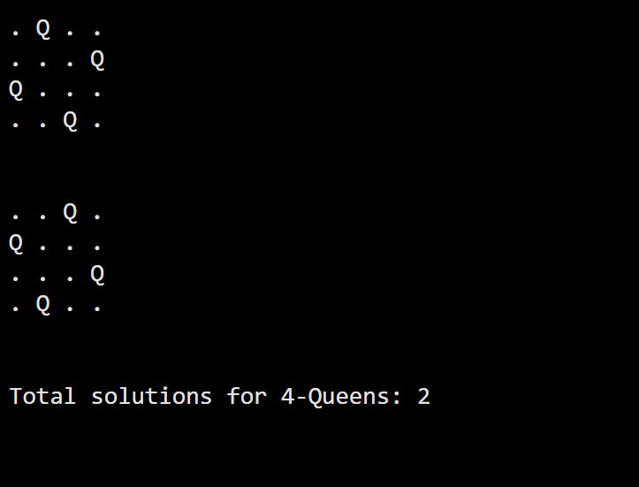

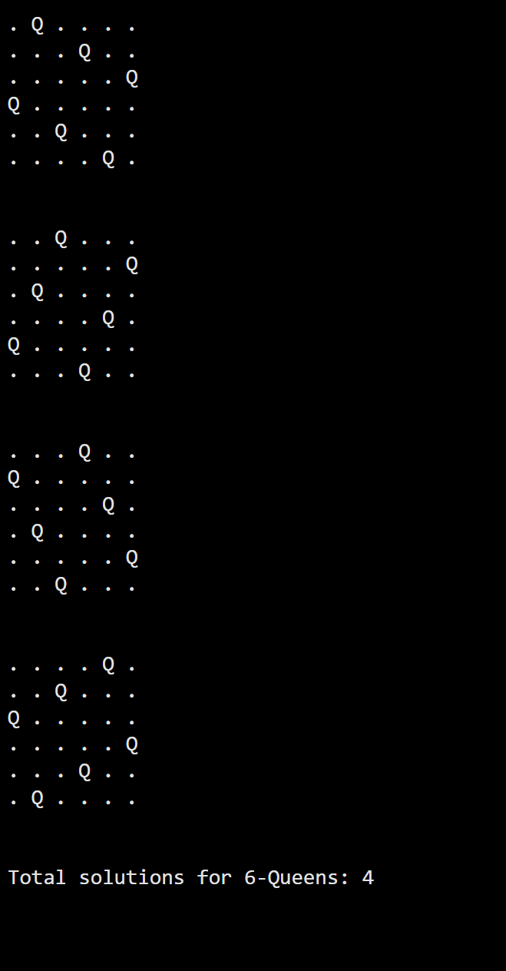

**REFERENCES/CREDITS:**

* **Python Official Documentation:** [**https://docs.python.org**](https://docs.python.org)
* **N-Queens Problem Explanation:** [**GeeksforGeeks**](https://www.geeksforgeeks.org/n-queens-problem-backtracking-3/)